AZLAN SAMEER ULLAH (242800)

M. ABDULLAH (242788)

[FINAL pROJECT.D-B]

**Project Overview:**

For this project, we will create an **Online Mobile Shop Database System** with a focus on managing products, customer orders, carts, and feedback. The system will support two distinct types of activities: customer interactions and store management.

**Customer Activities**: Customers will be able to browse mobile products, add items to their cart, place orders, and leave reviews based on their shopping experience.

**Management Activities**: The store managers will be able to manage carts and cart items, and view customer feedback for business improvement.

The system will be connected to a **MySQL database**, where all critical data including customers, products, orders, carts, cart items, and reviews will be stored and organized. The database design will use Entity-Relationship Diagrams (ERD) and normalization to ensure efficient storage and minimal redundancy.

Overall, the goal is to develop a simple yet powerful database that supports smooth online shopping operations and provides essential insights for business management.

**Planning Phase**

**PURPOSE:**

The purpose of this database project is to design and build an online mobile shop. It will manage customer information**, products, categories, carts, cartitems , orders and Reviews**. This project will help me understand how real-world databases work and how different parts of a system are connected. It will also improve my skills in planning, designing, and writing SQL queries.

**AUDIENCE:**  
Clients or Small Business Owners: This database can be useful for people who want to sell their products online. It helps manage products, customers, orders, and income in an easy and organized way.

**TEACHER:**  
My teacher will check this project to grade my work and see how much I’ve learned and understand the concept of database .

**FUTURE PROJECTS AND PERSONNEL USE:**  
I can also use this project later to build more advanced systems or include it in my portfolio to show my skills when applying for jobs, internships, or other opportunities.

**FOR SEMMESTER PROJECT:**

I can submit it to the teacher as the semester final project.

**Tables & Their Purpose:**

|  |  |
| --- | --- |
| Customers | It contain the information about the people who place orders |
| Products | It contain the information about products and items that store have |
| Order | Contains information about customer orders |
| Cart | |  | | --- | |  |  |  | | --- | | It contains the temporary storage of products selected by a customer before placing an order. | |
| Cart items | It contains the detailed list of products inside a customer's cart, including product ID, quantity, and price |
| Reviews | Customers reviews with rating and comments |

**ERD DIAGRAM**

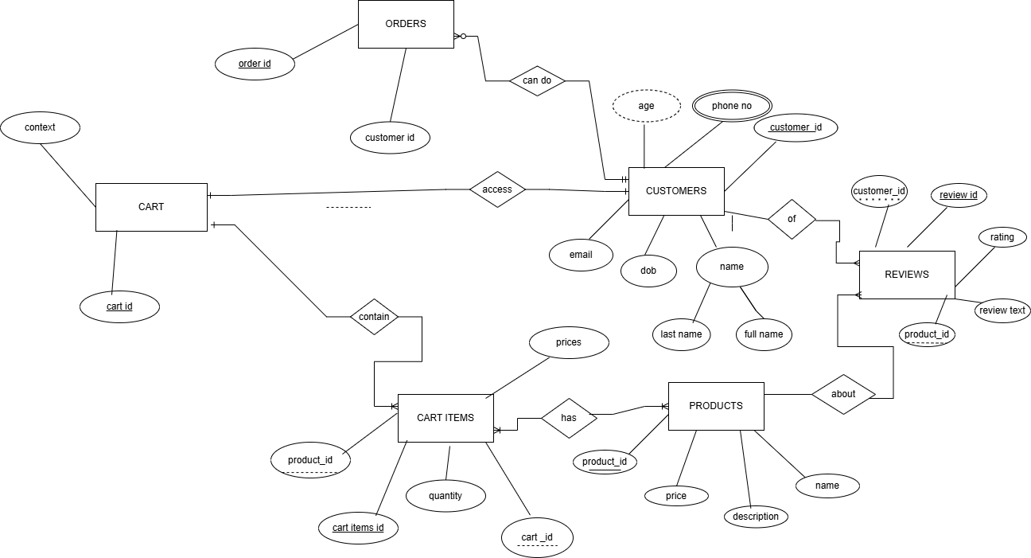

**SCHEMA** 